Uploading and Sharing Your Role Play Using Zoom
Windows-based Tutorial, similar setup for Mac Users
The following directions will be useful when you need to UPLOAD and SHARE your Role Play video. After your meeting is over, a window should appear with that recording. Steps 1-3 will help you find the video if you closed the window.

You will attach the video file to your Fordham Google Drive, share the link to the video with only those students who are using their Fordham account and have your link. No one else is able to view the video! The video will also play in the browser.

If you are looking for an old recording on your computer
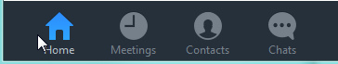
- Using the PC or Mac client, click on Meetings.

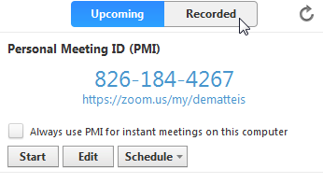
- Click on the Recorded tab.

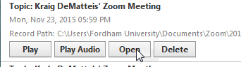
- Look for the date of your recording and click OPEN

- A folder with the files for that meeting will appear. This folder’s default location is is located under [username]/Documents/Zoom/[Year-Month-Day Time]/. Find and attach the .mp4 file only.
